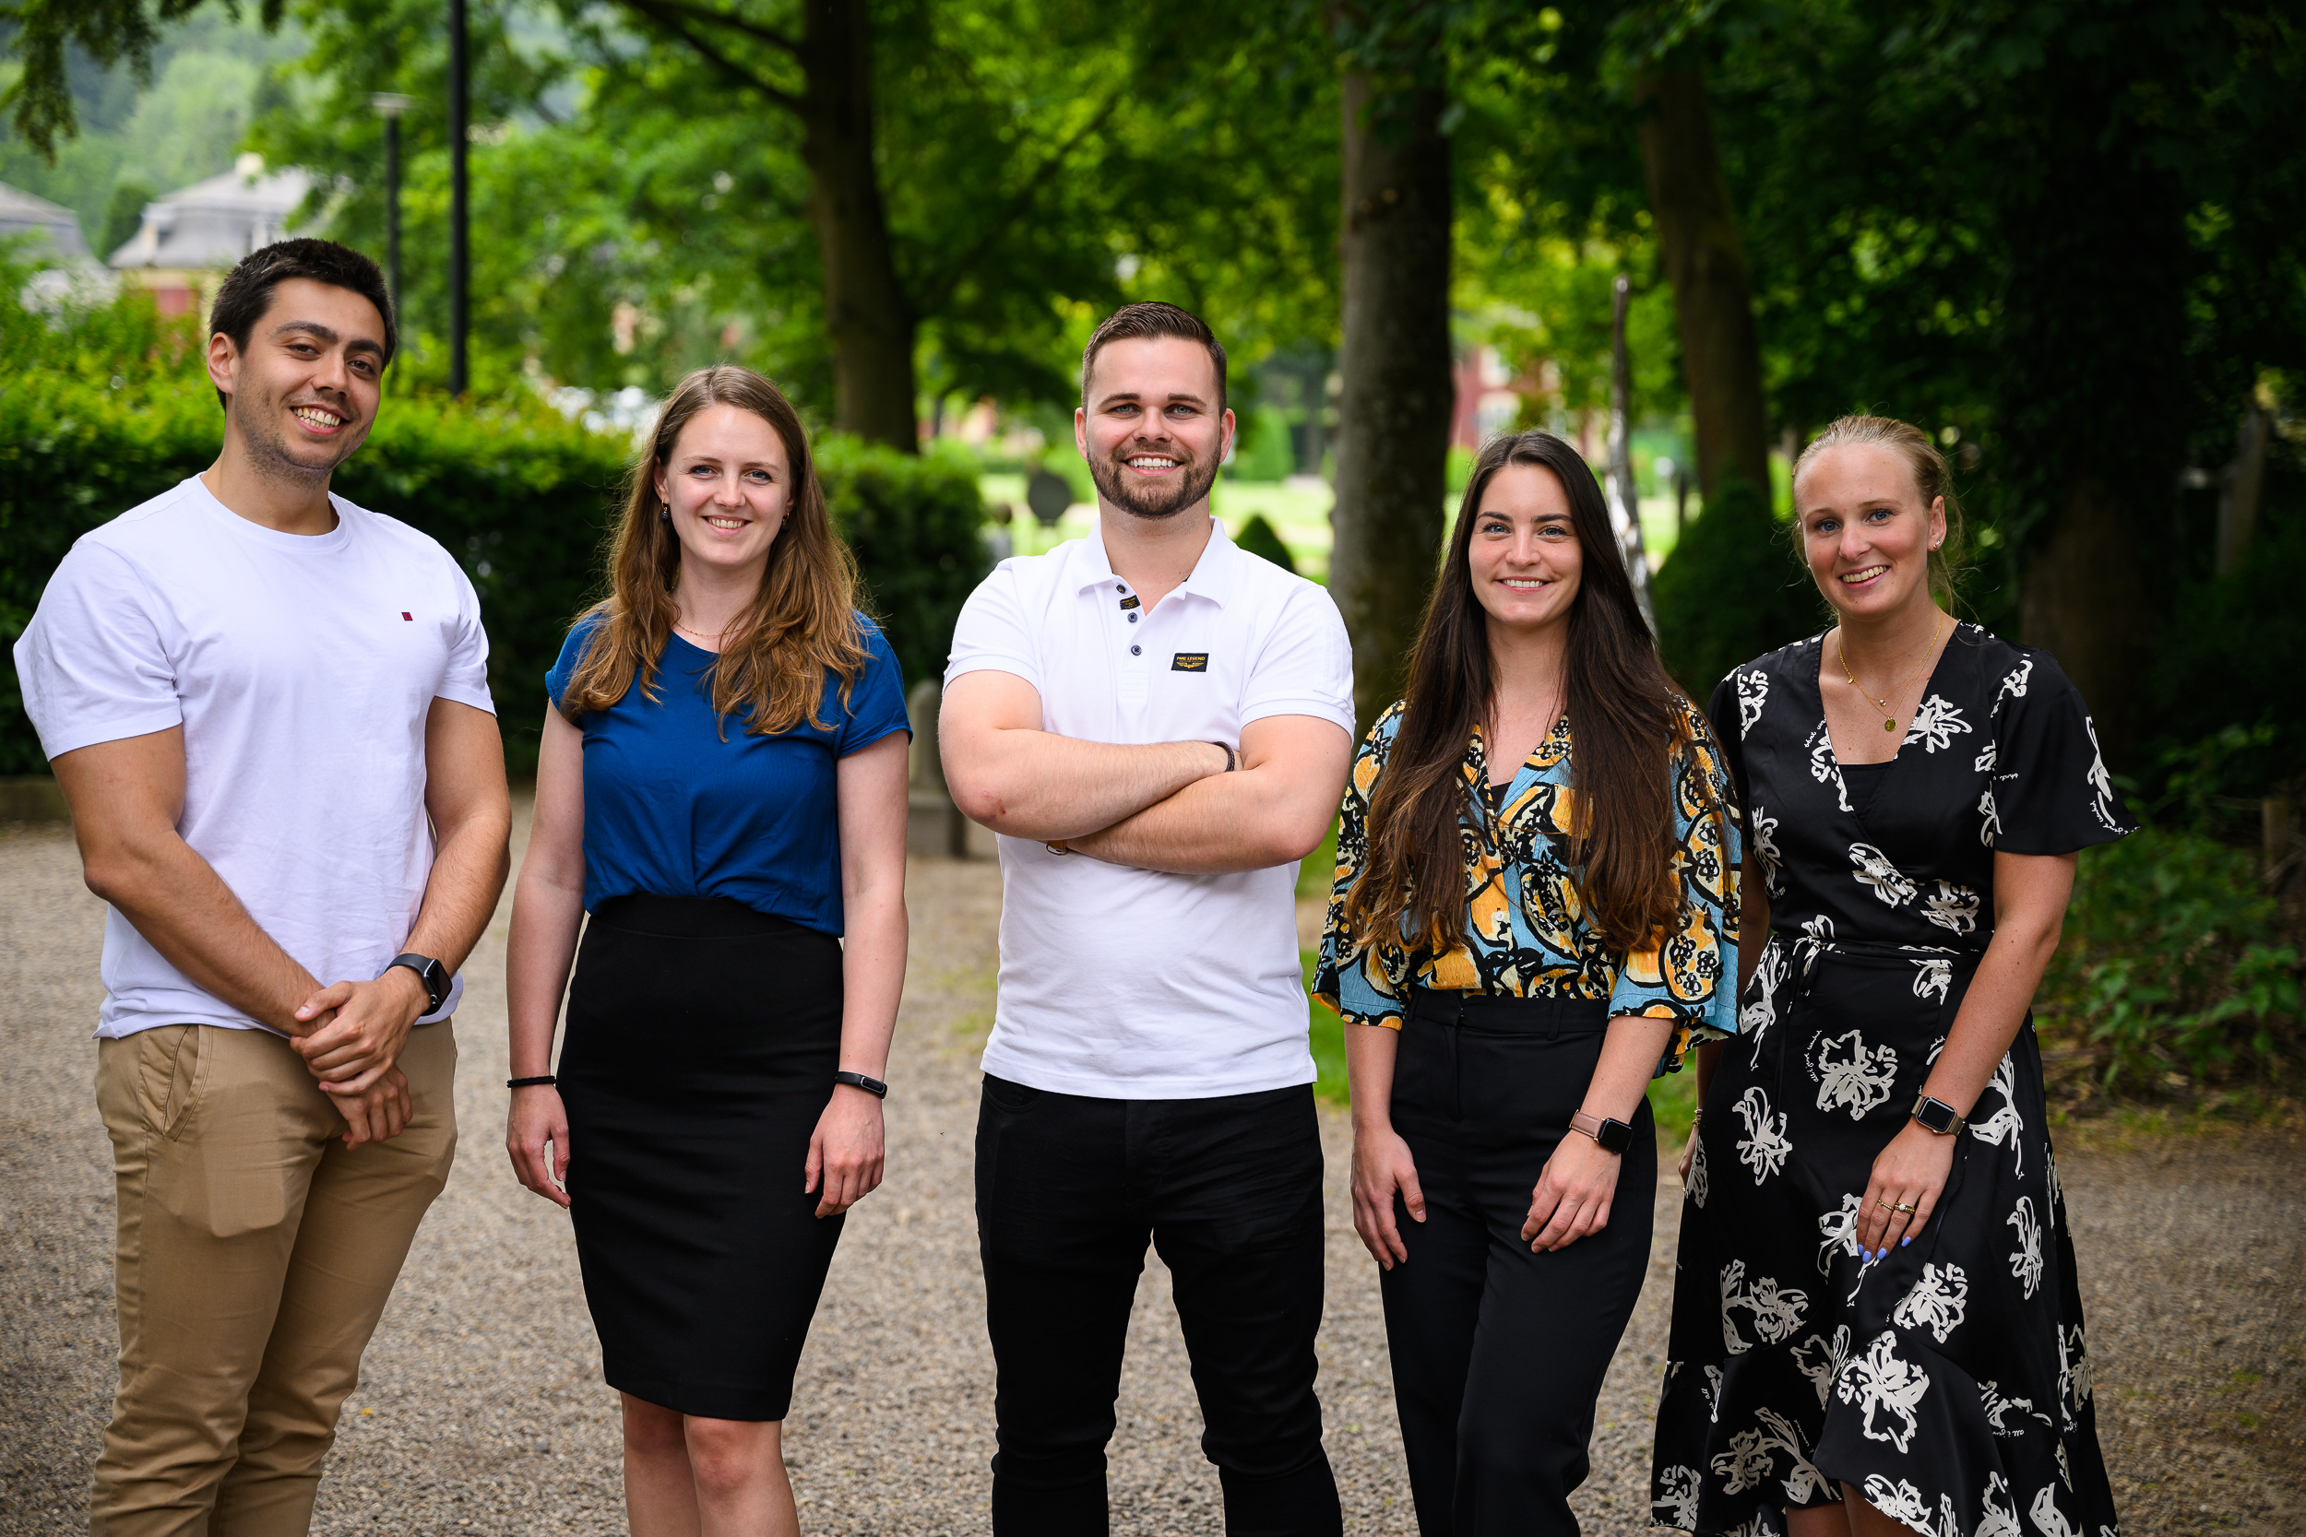

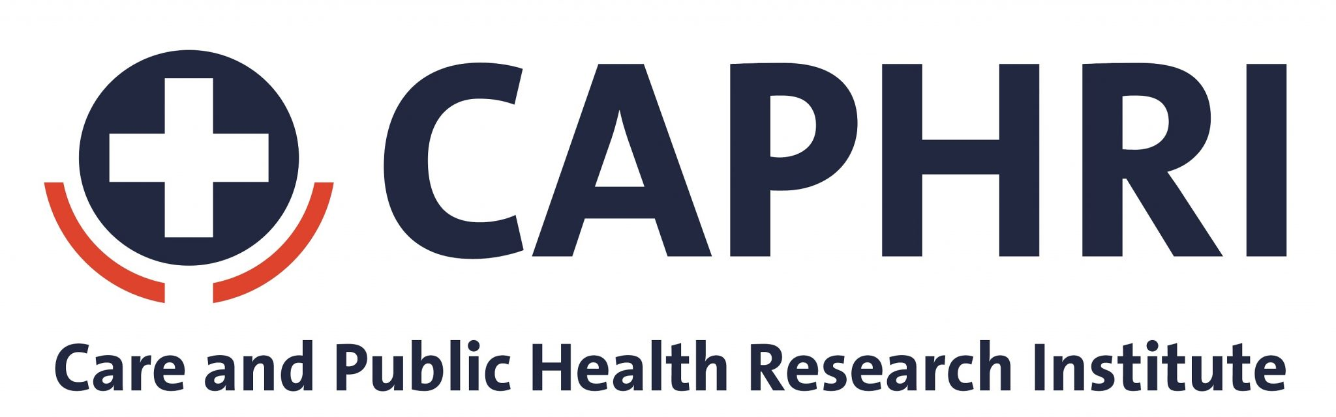

Year report 2023 CAPHRI PhD representatives
CAPHRI, Universiteit Maastricht

Diogo Lopes Leao (VHC)
Quincy Merx (ALT-C)
Chrissy Moonen (HISP)
Frederike Mulder (FPR)
Ken Peeters (OPC)
Lieve Vonken (PHPC)
Table of contents

1. Our goals 3
2. CPCP en FPC 3
3. CaRe 3
4. PPM meetings 4
5. CAPHRI PhD Post/UMployee 4
Summary of PhD Posts 4
Summary of UMployee contributions 4
Reflection 4
6. Activities 4
CAPHRI PhD Webinars: David Shaw (March 14th) and Vivian Braeken (April 11th) 4
Evaluation 5
Reflection by organizers 5
Prospects 5
Spring Meeting April 20th 6
Goal of the Spring Meeting 6
Evaluation of the Spring Meeting 6
Reflection by organizers 6
Kick-off Academic Year Meeting 6
Winter drinks, 7th december 8
Reflection 8
7. Warm welcome new PhDs 8
Welcome meetings 8
8. Finances 9
9. Any other business 9

1. Our goals
Our goals as CAPHRI PhD representatives can be summarized in three categories:
- We represent the voice of all CAPHRI PhD students and aim to identify possible issues and/or improvements and communicate these to the CAPHRI board. Also, we will provide input to the CAPHRI board when the perspective of PhD students is warranted for policy decisions.
- We organize meetings that contribute to creating a CAPHRI PhD community. We aim to include all CAPHRI PhD students. When possible we aspire to organize meetings that combine a theoretical aspect with a social aspect.
- We communicate relevant information to all CAPHRI PhD students via different platforms (e.g. PhD Post/UMployee). Also, we act as a first contact for CAPHRI PhD students who have questions.

2. CPCP en FPC
The Central PhD Candidates Platform (CPCP) met four times in 2023 (February, July, September, December 2022). In April and October 2023, a meeting took place in the presence of the rector of Maastricht University. Quincy participated in these meetings. In this university-wide platform, issues concerning PhD candidates, both interfaculty and (inter)national, were discussed. In 2023, some of the topics included:
- PhD input and elaborate on Reward and Recognition
- New PhD regulations
- Printing and reception costs for the defense
- Rules around external PhDd and scholarship candidates

The Faculty Promotion Committee (FPC) of FHML advises the board on a wide range of promotion-related matters. The committee also serves as a platform for the exchange of knowledge and experiences, as well as the discussion of relevant developments and operational issues within and among schools/institutes. Quincy represented CAPHRI on behalf of the PhD candidates in meetings 160 through 164, participated in the preparatory meeting, and also discussed the on the agenda items of CPCP in the FPC. Until April 2023, Monique had fulfilled these tasks.
Topics that have been addressed (not exhaustive) include:
- Hybrid working for PhDs
- The role of confidential advisors
- New PhD regulations
- The positioning of external PhDs
- PhD courses from FHML
- Scholarship students
- Social safety at MUMC+

3. CaRe
Of the CAPHRI PhD representatives, Diogo (After April) and Lieve (before April) represented CAPHRI in the CaRe PEC-meetings. Lieve attended the meeting on the 24th of January. Diogo attended the meeting on the 30th of May. During these meetings, the CaRe Days were discussed. On the 11th September another meeting was held, in which possible topics for the CaRe Days were discussed. Ethics and AI are possible topics, but a final decision has yet to be made.

4. PPM meetings

In 2023, the PPM meetings took place on the following dates: 14.02.2023, 29.06.2023, and 03.10.2023. The following items present an overview of the items that have been covered during these PPM meetings:
- CAPHRI visitation 2023
- CAPHRI Day
- Welcome meetings
- Kick Off meeting
- Winter meeting
The events are further explored at item 6, Activities.

5. CAPHRI PhD Post/UMployee

Summary of PhD Posts
The CAPHRI PhD Post was sent monthly and generally contained the following items:
- Announcements
  - From the PhD representatives
- Events
  - Specific events per month
- Courses and workshops
  - Specific workshops per month
  - Language Center
  - Staff Career Center
  - University Library
  - PhD ceremonies
- Leisure
  - UM Sports
  - Studium Generale
  - PhD Academy
- CAPHRI PhD Guide
- Contact persons for PhD candidates
- Contact us

Summary of UMployee contributions
A CAPHRI PhD Community was created on UMployee. Currently, this community has 72 group members. A large number of messages have been posted on UMployee in the last year. In total, over 100 items have been posted since the creation of the community. It has become apparent that there have been little to no responses from other CAPHRI PhD students to these messages.

Reflection
As of the CAPHRI Day, the UMployee CAPHRI PhD Community is a closed group on UMployee. Since then, we have posted several messages with the goal of engaging CAPHRI PhD candidates. However, the reach of and response to these messages has been very low. The PhD Post remains the preferred method for reaching CAPHRI PhDs. We believe that the use of the UMployee CAPHRI PhD Community needs to be promoted for it to fulfill its potential.

6. Activities

CAPHRI PhD Webinars: David Shaw (March 14th) and Vivian Braeken (April 11th)
Both webinars were online and were attended relatively well. The webinar about Research Quality Assurance was given by David Shaw (±21 attendees) and the webinar about research Funding for PhD Candidates was given by Vivian Braeken (±23 attendees). David Shaw had approached us to organize a webinar, and Vivian Braeken was approached by Francine because of the link with the topic of the Spring Meeting.

Evaluation
The Quality assurance webinar evaluation form was filled in by 5 respondents. The overall average assessment grade was 8.8 out of 10 (range 8-10). The expectations of the participants were met (average 4.4 out of 5; range 4-5) and believe the content of the webinar will be useful in their work (average 4.6 out of 5; range 4-5). David Shaw was perceived to be knowledgeable about the workshop topics and able to answer questions (average 5 out of 5; range 5). The possibility to ask questions, information on data sharing, how to handle personal data, and the ethical committee was appreciated.

The Research Funding for PhD Candidates webinar evaluation form was filled in by 8 respondents. The overall average assessment grade was 8.5 out of 10 (range 7-10). The expectations of the participants were met (average 4.25 out of 5; range 3-5) and believe the content of the webinar will be useful in their work (average 4.24 out of 5; range 3-5). Vivian Braeken was perceived to be knowledgeable about the workshop topics and able to answer questions (average 4.75 out of 5; range 4-5). PhDs appreciated the overview of what grants are available and how high the success rates are. Yet, they described that most grants did not apply to their situation and that they were slightly disappointed by the limited grant opportunities. For one, the workshop mainly discussed grants for researchers based in the Netherlands.

Reflection by organizers
The online webinars are an easy and effective way to offer information to PhD candidates and to keep CAPHRI on their radar.

Prospects
As of 2024, Francine and Chantal will organize webinars every year (e.g., David Shaw, Vivian Braeken, Milena Pavlova).

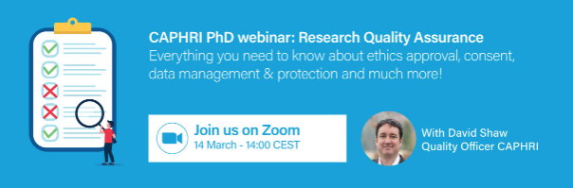

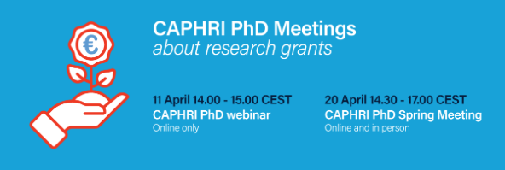

Spring Meeting April 20th

Goal of the Spring Meeting
Many PhD candidates wonder about their job prospects after their PhD. Applying for grants is one option to ensure a job. Grants can also be an option to enrich your experience of being a PhD candidate (e.g., grants to go abroad). The goal of the Spring Meeting and the webinar by Vivian Braeken was to inform PhD candidates about the option to apply for a grant (mainly in the webinar) and to provide them with experiences and tips and tricks from people who applied for a grant themselves (mainly in the Spring Meeting).

Evaluation of the Spring Meeting
Spring Meeting evaluation form was filled in by 6 respondents. The overall average assessment grade was 9 out of 10 (range 7-10). The expectations of the participants were met (average 4.3 out of 5; range 3-5). Specifically, participants believe the content of the lecture by Daan Westra will be useful in their work (average 4.3 out of 5; range 3-5) as well as the content of the panel discussion (average 3.7 out of 5; range 2-5). They believed the content of the panel discussion would help them to write a grant application in the future (average 3.3 out of 5; range 2-5). Participants appreciated the relevance of the topic, the different types of grants, and the different aspects of grant writing that were covered. Moreover, they liked the concrete and personal experiences of the speakers. Suggestions for the next meeting were to include more examples, more information on ‘small’ grants, more explanation about the role of the supervisors and sending an Outlook invitation for the meeting.

Online participants rated the spring meeting with an 8 out of 10 (range 6-9; n=5) and suggested to next time also show the audience.

Reflection by organizers
The attendance at the meeting was very low: ±13 online and 5 in-person participants of whom 5 PhD representatives. Next time, a similar event should be scheduled earlier, the invite should be clearer, especially if two events (i.e., the webinar and the Spring Meeting) are combined in one invite, and reminders should be sent.

Kick-off Academic Year Meeting
On September 29th, we held the annual kick-off meeting, setting the tone for the new academic year. The meeting consisted of two parts: a hybrid information session and an on-site social event.

Part 1: Information Session
The first session was dedicated to introducing essential resources and providing an informative workshop. The first part of the program consisted of the following components:
- PhD-rep Diogo Lopes Leao welcomed both online and on-site attendees.
- Sylvia Evers, Scientific Director of CAPHRI, launched the academic year and shared CAPHRI's goals.
- PhD-rep Diogo Lopes Leao presented the UM's complaints center, ensuring access to support.
- PhD Confidential Advisor, Milena Pavlova, highlighted confidential advisory services, promoting a safe space for concerns.
- PhD-rep Chrissy Moonen reported that Lieve, Frederike and Ken are quitting as PhD-reps and want to hand over their duties. She recruited for new PhD reps.
- Following a short coffee and cake break, we engaged in a workshop on work-life balance and personal boundaries. Dr. Jordi Cabanas-Danés and Dr. Mandy X. Hu led the workshop, fostering discussions on achieving balance. The session aimed to help attendees define their work-life equilibrium and set boundaries for personal well-being.

Part 2: Social Event
Around 15:00, we departed to Olround Maastricht for the social event (Prison Island). Attendees were divided into groups and faced skill-testing challenges in a cell complex.
The goal was getting to know other PhDs, encourage teamwork and collaboration while having a great time.

In summary, our annual kick-off meeting on September 29th fulfilled its objectives: orientation, resource introduction, promoting balance and boundaries, and fostering teamwork and collaboration. These sessions have set a positive tone for the upcoming academic year, equipping us to tackle the challenges and opportunities ahead.

Evaluation of the Kick-off Meeting
The first part of the kick-off meeting was attended by 29 participants: nine online, and 20 onsite. The evaluation was completed by eight (28%) attendees, evaluating this part of the meeting with an overall score of 7.4/10. The usefulness of the information about the support system and the introduction about the departments was underlined by two individuals. One person already attended the workshop during the CaRe days. Suggested future topics were: grants, job search, challenges and burnout in academia.

Twenty-three individuals (including 4 reps) participated in the second part of the Kick-off Meeting, Prison Island. This part was evaluated by 16 people with an overall score of 9/10. In order to prevent bias, the CAPHRI PhD-reps did not fill out the evaluation. Attendees most enjoyed getting to know other PhDs due to the mixed groups, and the games themselves. Point of improvements were to include drinks and time to talk to the other attendees. Furthermore, there was a slight delay and some parts at Prison Island were only in Dutch.

Reflection by organizers
The kick-off meeting was a success from the organizers' perspective. We receive a positive evaluation score of 7.4/10 for the initial session. The second part, Prison Island, brought even more excitement, with 23 participants and an outstanding 9/10 rating. On average, the Kick-off meeting was evaluated with an 8.2/10. We're particularly delighted that attendees appreciated the opportunity to connect with fellow PhDs from diverse backgrounds. The persistent issue of a high number of no-shows has been a long-standing concern for us. However, we are dedicated to implementing more robust measures to tackle this problem in the future. We also continue to look for a room that best facilitates a hybrid meeting.

Organizers are grateful for this enthusiastic response and are committed to making future events even more engaging, addressing the suggested improvements.

Winter drinks, 7th december
The Winter Meeting took place on December 7th, 2023, from 17:00 to 22:00 at Kruithuis, Maastricht University. During this on-site event, we planned to have senior researchers share insightful anecdotes about their research challenges. With this, we aimed to underscore that everyone makes mistakes, and making mistakes is not a negative occurrence. However, due to the struggles we had with finding senior researchers willing to join the winter meeting we decided to cancel this part and make the winter meeting a purely social event. We did decide to order some games (What do you meme, black stories and exploding kittens), by doing this the participants where free to decide whether they wanted to play a game or just network and socialize. Alongside this, we ordered free food and drinks, we ordered “borrelplanken” and a “borrelkar” through the catering of the UM and we have ordered some complimentary pizza’s via Thuisbezorgd. The primary goal of this gathering is to foster connections, facilitate networking and most importantly, have fun!

Reflection by organizers
The winter drinks were a success from the organizers' perspective. We received positive reactions from the participants. The amount of participants that have actually participated was 15, whereas 29 people registered. We're particularly delighted that attendees appreciated the opportunity to connect with fellow PhDs from diverse backgrounds.

Organizers are grateful for this enthusiastic response and are committed to making future events even more engaging, addressing the suggested improvements.

Reflection
The invites we send for activities have improved in 2023. Important aspects of the improved invites are (a) that participants are asked to agree to pictures being taken; (b) the calendar file of the meeting that can be downloaded from the confirmation email (“.ics”); (c) the reminder that is sent just before the activity. The persistent issue of a high number of no-shows has been a long-standing concern for us. However, we are dedicated to implementing more robust measures to tackle this problem in the future. We also continue to look for a room that best facilitates a hybrid meeting.

7. Warm welcome new PhDs

Welcome meetings
Two Welcome Meetings were held on 2nd of February and 7th of September.

Recap: we introduced this kind of meeting because we got signals that not every PhD candidate got the same information at the start of their PhD, besides the introductory e-mail sent by CAPHRI. Also, we thought it would be useful to meet the people of CAPHRI and other starting PhD’s. Therefore, we decided to hold this kind of Welcome Meeting 2-3 times per year for the PhD students that started in the last 4-6 months.

The organization was introduced (management, research lines, departments/living labs, funding advisors, quality assurance officer), as well as the community and the PhD community (PhD administrative coordinator, community coordinator, confidential advisors, representatives). Additionally, information regarding documents PhD candidates need to pay attention to were introduced (TSP and PRP), as well as the TRACK system and several topics that can be accessed through the CAPHRI website. At the end, there was time for any questions the new PhD candidates might have had. The PhD candidates also had some time to chat and get to know each other.

Reflection by organisers
There was no evaluation sent out. However, from subsequent reactions, it can be concluded that it was very useful. Additionally, there were a good number of participants.
There were questions regarding the UMployee registration, and it was decided afterwards that FHML marketing & Communications would invite a list of all currently active PhDs to register for UMployee.

8. Finances

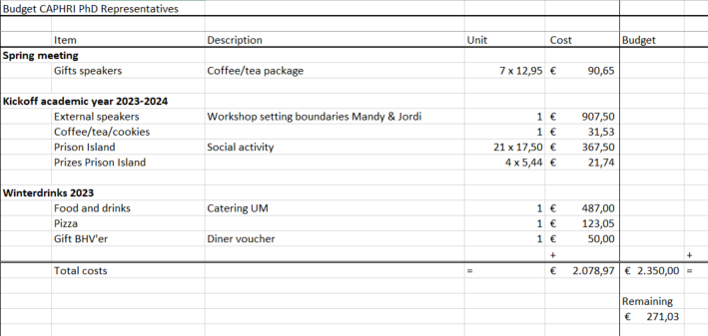

We approached Proefschriftmaken.nl for sponsoring. They decided to sponsor 350 euros for our activities. In return, they were able to talk about their services at our Spring Meeting and distribute some goodies to our PhD students.

Starting 1st January 2024, Diogo will take over the finances from Ken.

9. Any other business
The “roof tile construction” works well. Chrissy, Diogo and Quincy joined the team in 2023 to replace Monique and to complete a team of representatives from all research lines. Frederike, Ken and Lieve will be replaced as of January 2024.

